**Introduction**  
* **Graph G = (V, E)** is a **collection of sets V and E**  
* **V** => **collection of vertices**  
* **E** => **collection of edges**  
* **Edge** => **Line connecting 2 vertices**  
* **Edge**: **(u, v)** => **u, v belong to the set of vertices V**  
* We have 2 types of graphs:  
**Undirected Graph  
Directed Graph**  
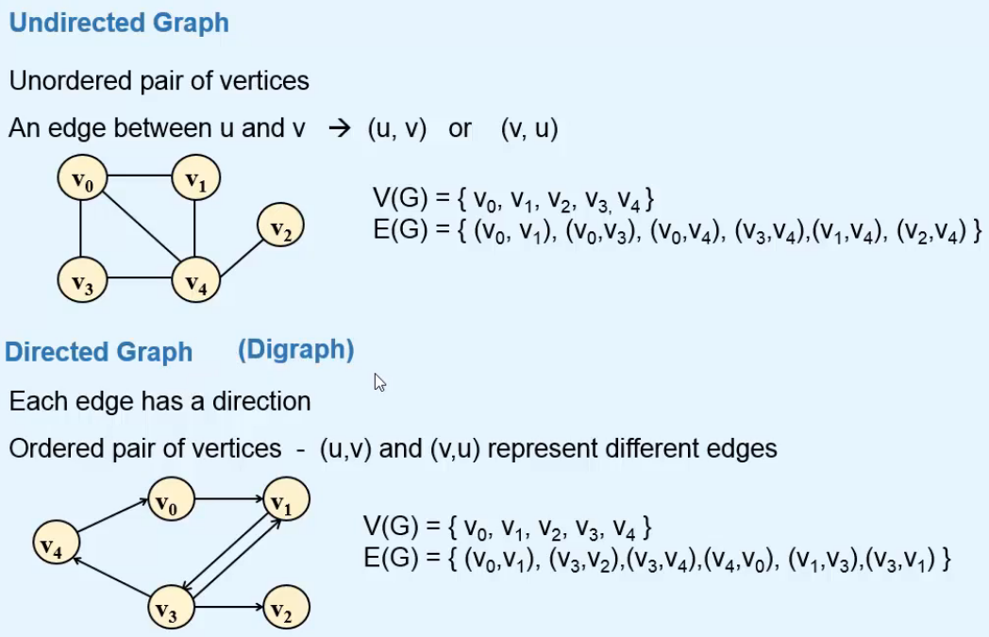  
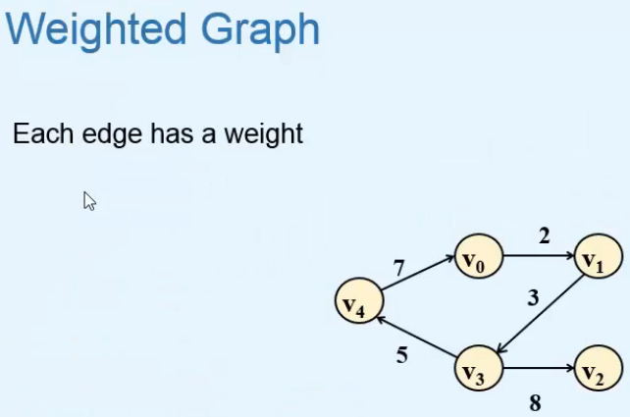  
**Weight** => may represent **Distance** or **Cost** associated with the edge.  
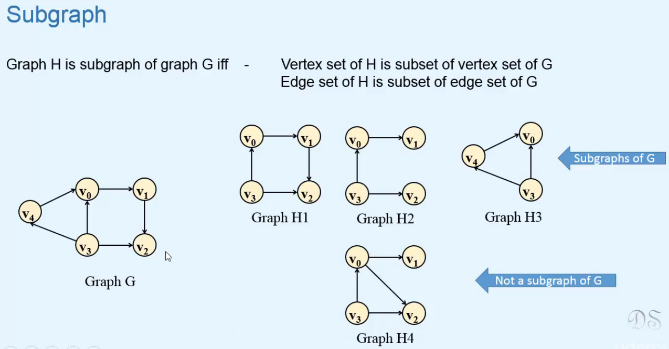

**Terminology**  
**Adjacency** => a relation between 2 vertices of a graph.  
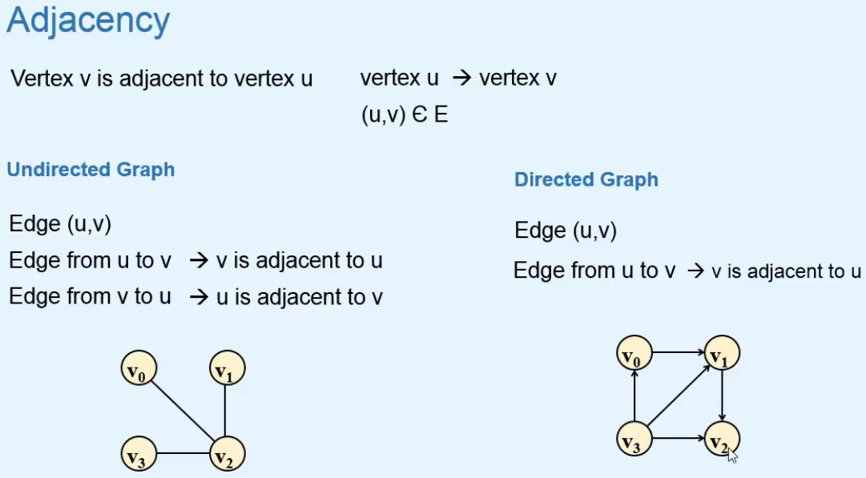  
=> In the Directed Graph,   
V1 is adjacent to V0  
V0 is NOT adjacent to V1  
V3 has 3 vertices that are adjacent to it  
**Incidence** => a relation between a vertex and an edge of a graph  
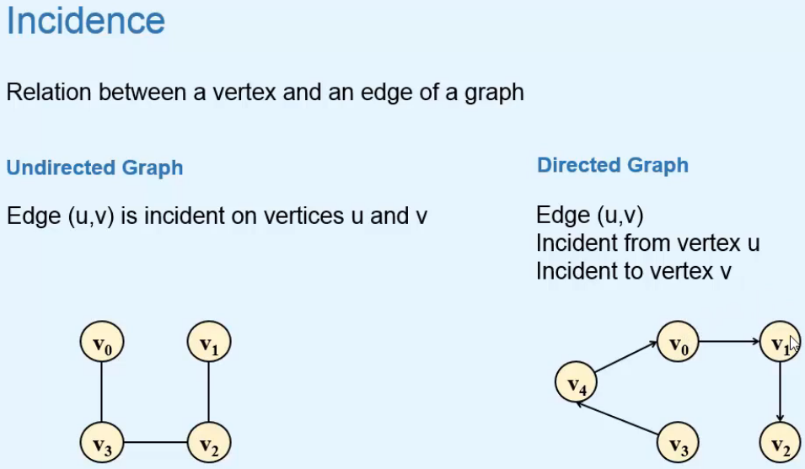  
=> In the Directed Graph, the the edge (V4, V0) is incident from vertex V4 and incident to V0.  
**Path** => **a sequence of vertices connected by edges**.  
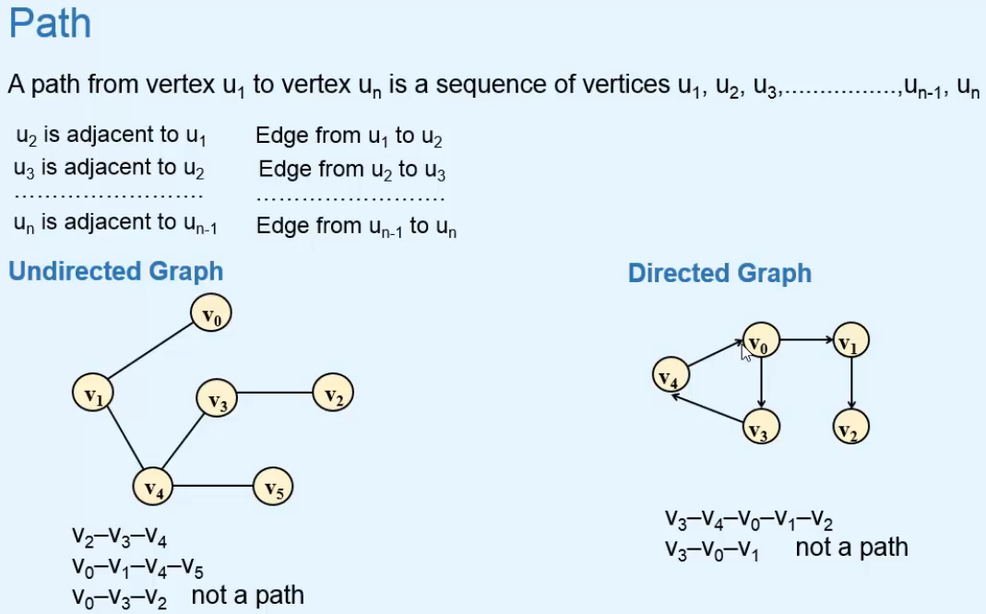  
**Length of a Path**  
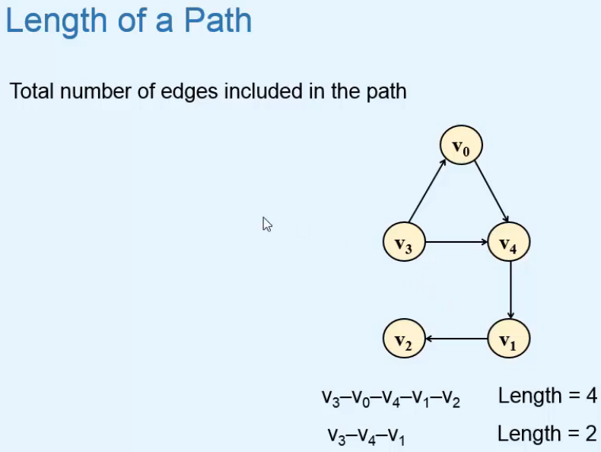  
**Reachability**  
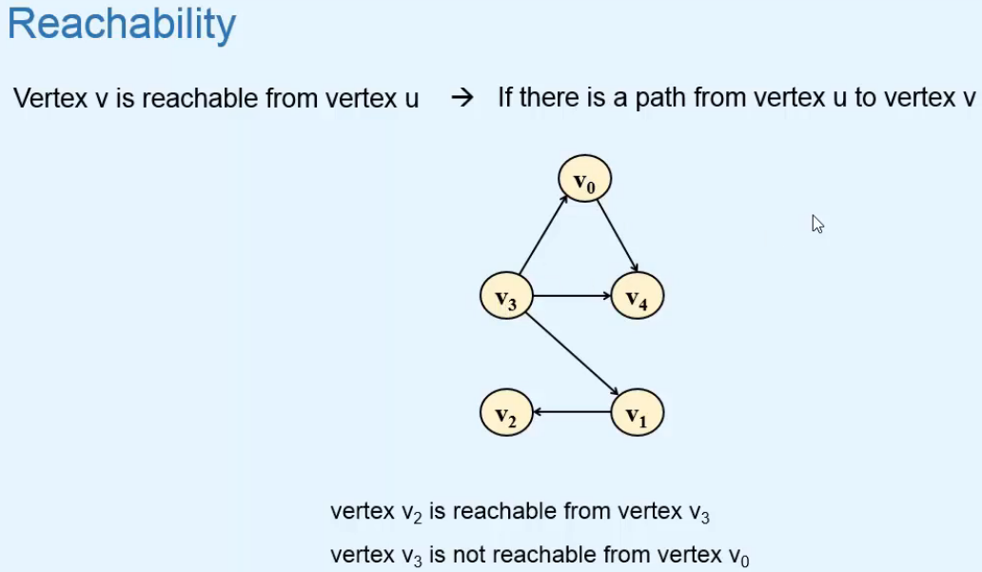  
**Simple Path**  
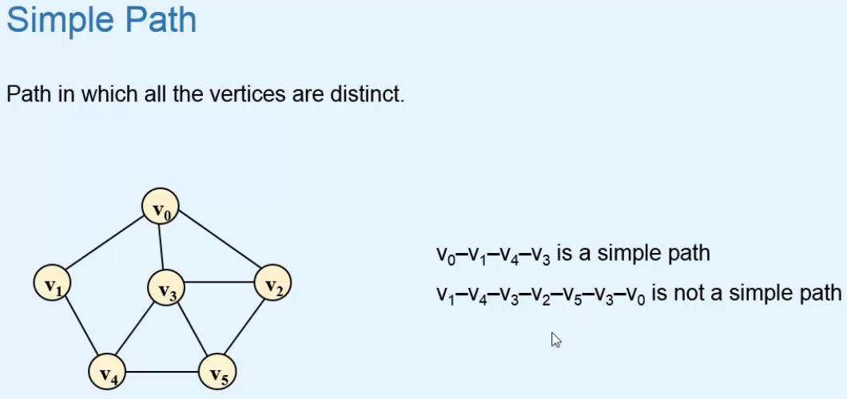

**Degree**  
=> In the undirected graph, the degree of V0 is 3.  
**Indegree  
Outdegree**  
=> In the directed graph, the indegree of V3 is 1 and outdegree is 3, the degree is 4.  
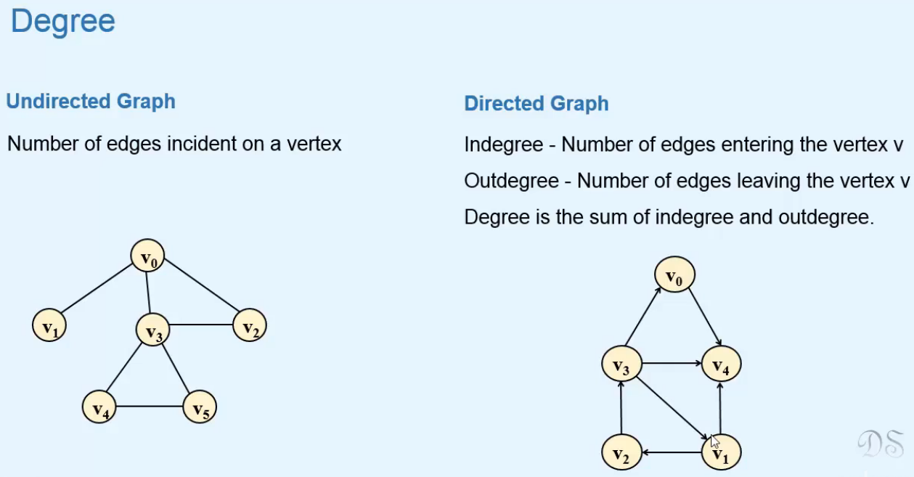  
**Maximum edges in a graph**  
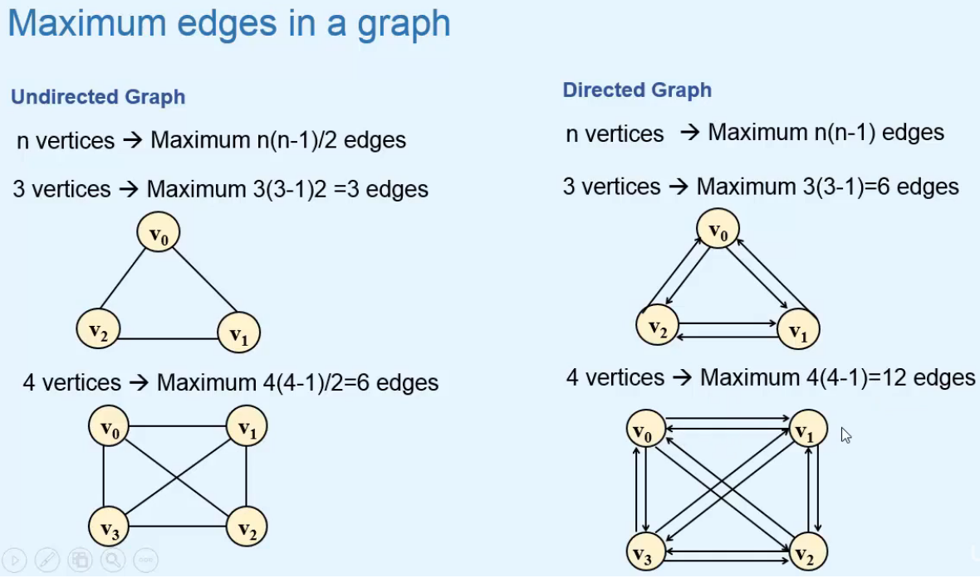

**Cycles**  
**Cycle** => **a Path in which the first and last vertices are the same**.  
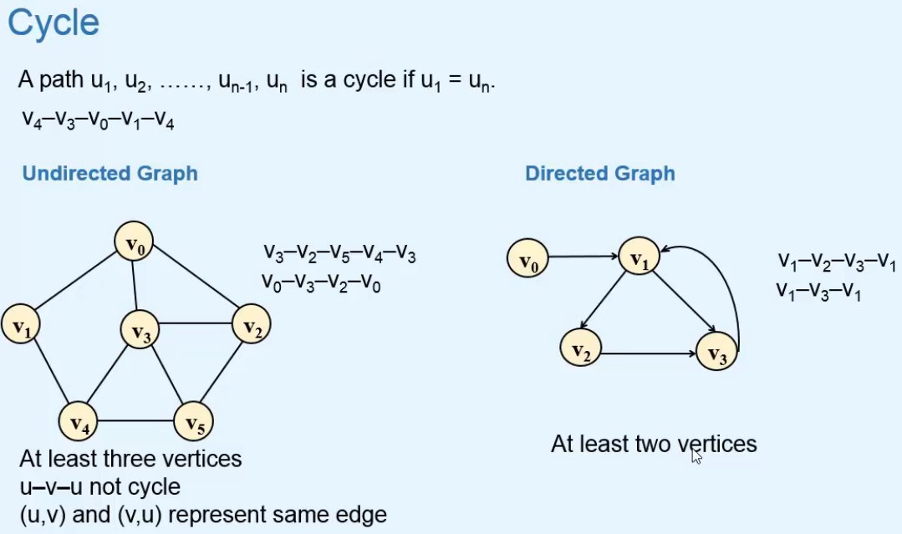  
=> Undirected Graph => In a cycle, there must be at least 3 vertices.  
=> Directed Graph => In a cycle, there must be at least 2 vertices.  
**Simple Cycle => all the vertices except for the first/last one are distinct.**  
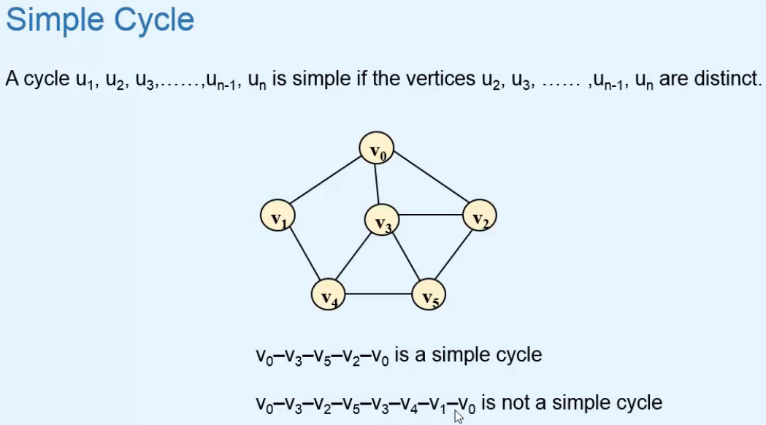  
**Cyclic Graph  
Acyclic Graph**  
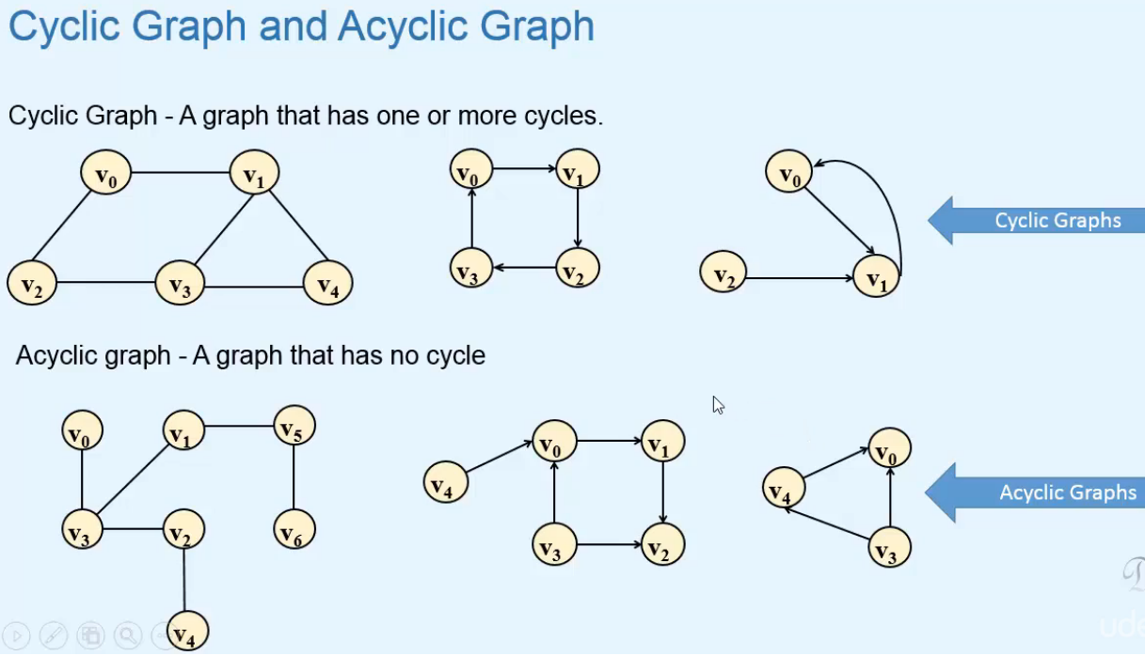  
**DAG** => **Directed Acyclic Graph**  
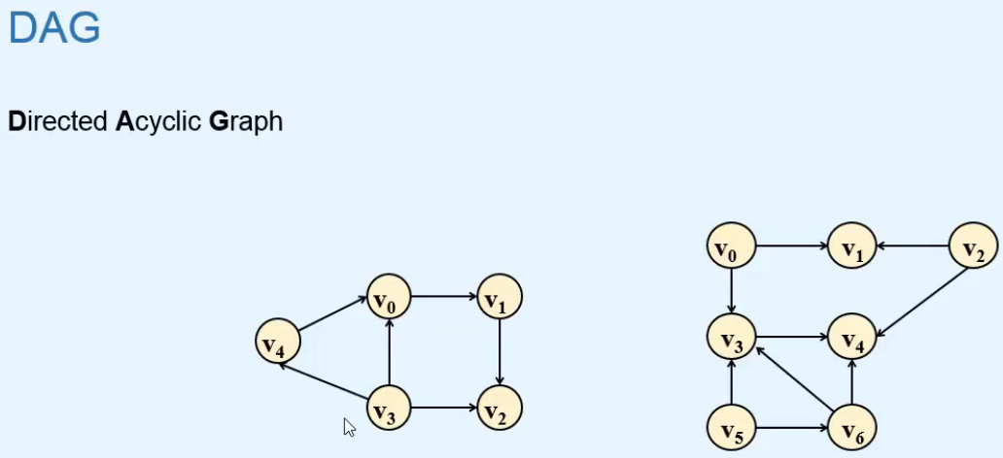

**Connectivity in Undirected Graph**  
**Connected** **Graph**  
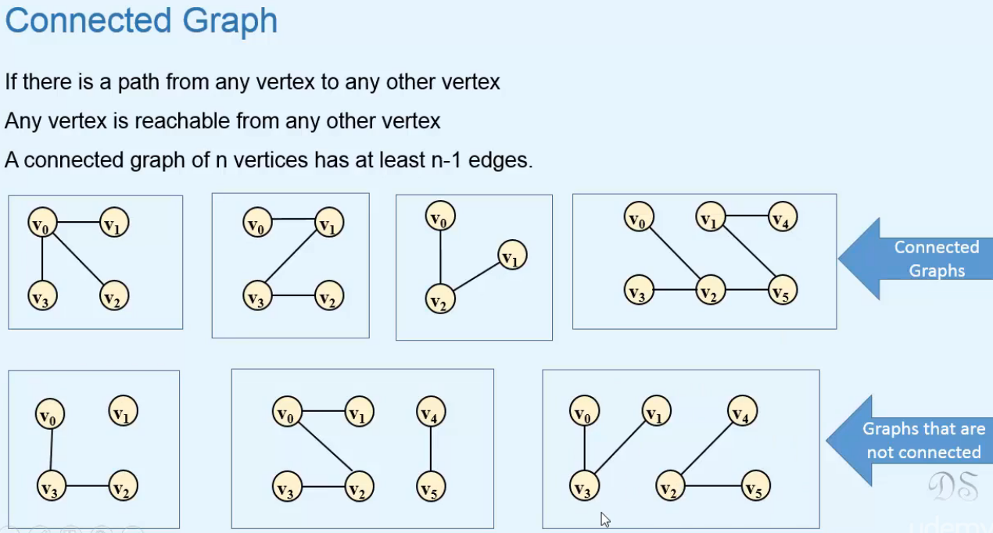=> The last graph has 6 vertices and 4 edges, n - 1 = 5, the number of edges is < n -1, not connected.  
**Connected** **Components**  
* A graph that is not connected consists of different parts that are connected.  
**Maximal Connected Subgraph** => **connected component is a subgraph in which all the vertices are connected and it’s not possible to add any other vertex to it while retaining its connectivity property**.  
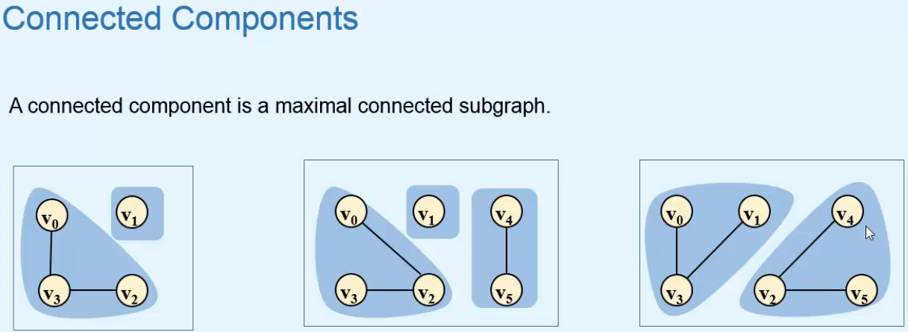

**Bridge**  
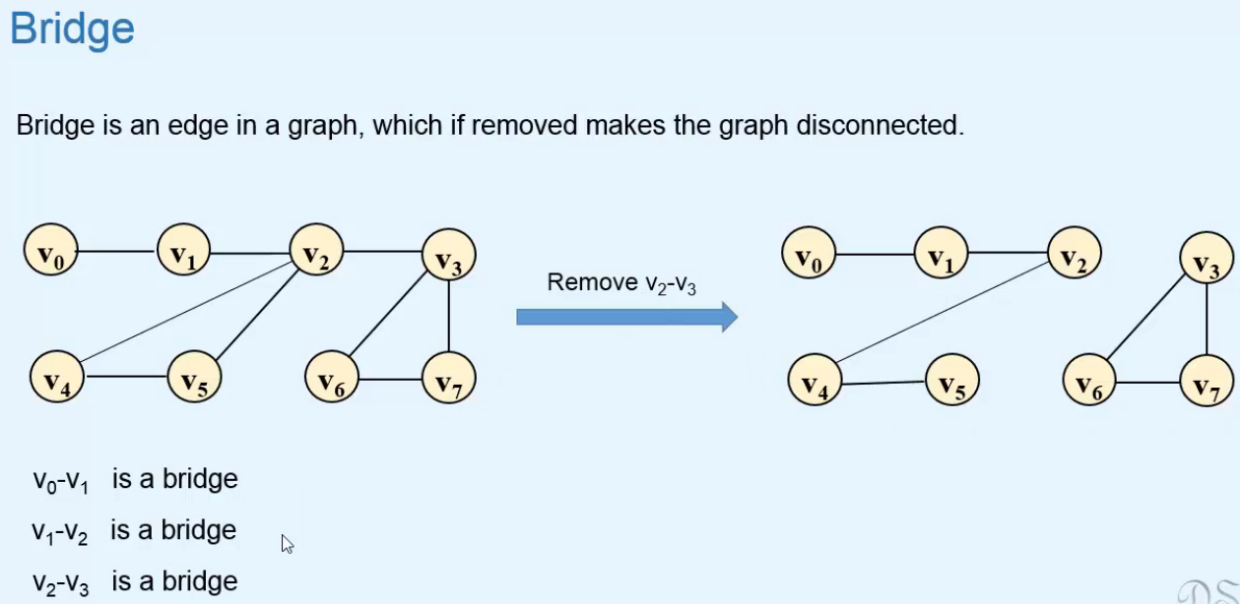  
**Articulation Point**  
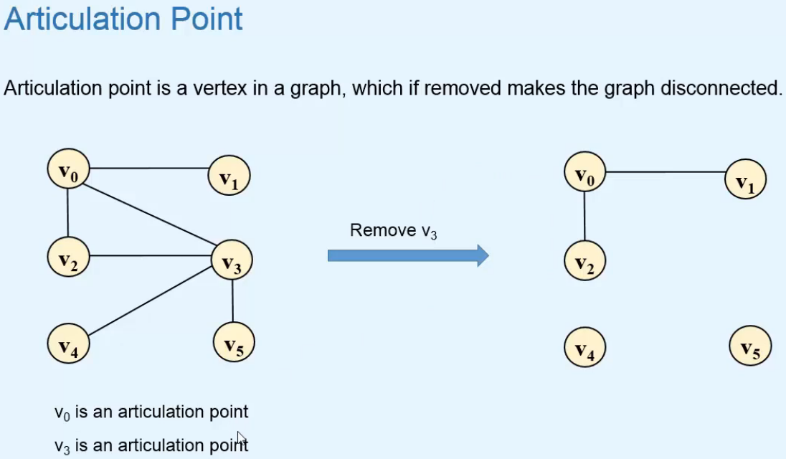  
**Biconnected** **Graph**  
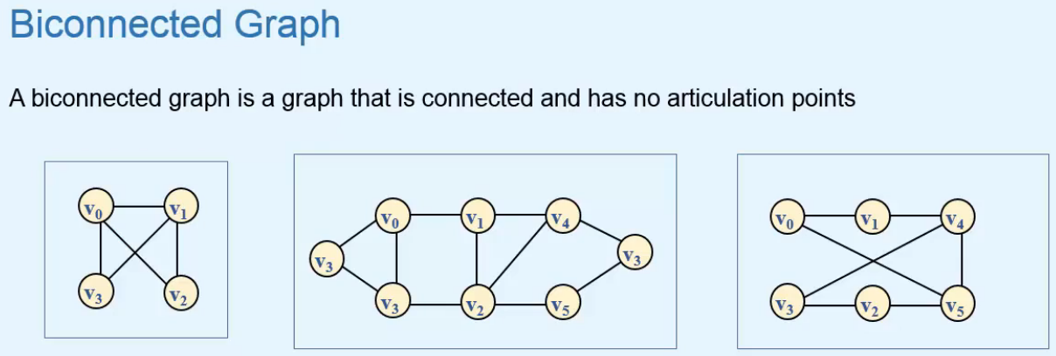

**Biconnected** **Components**  
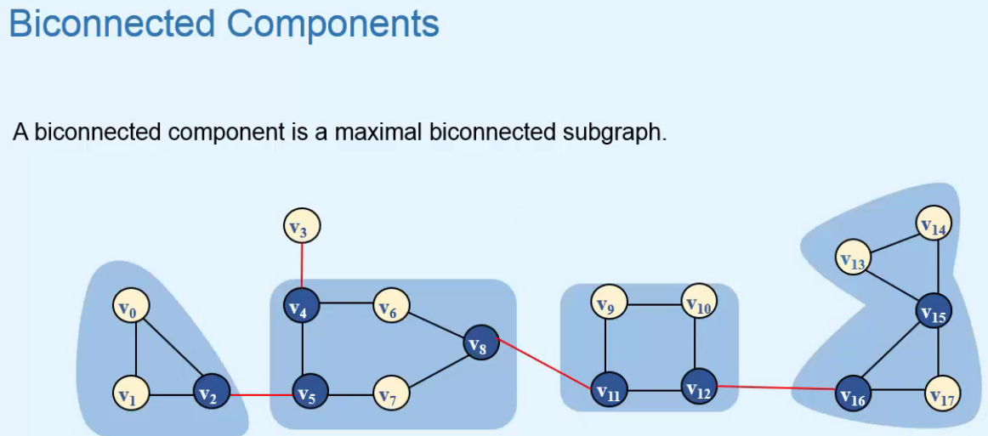  
=> **This whole graph is not biconnected but it has 4 biconnected components**.

**Connectivity in Directed Graphs**  
**Strongly Connected Graph**  
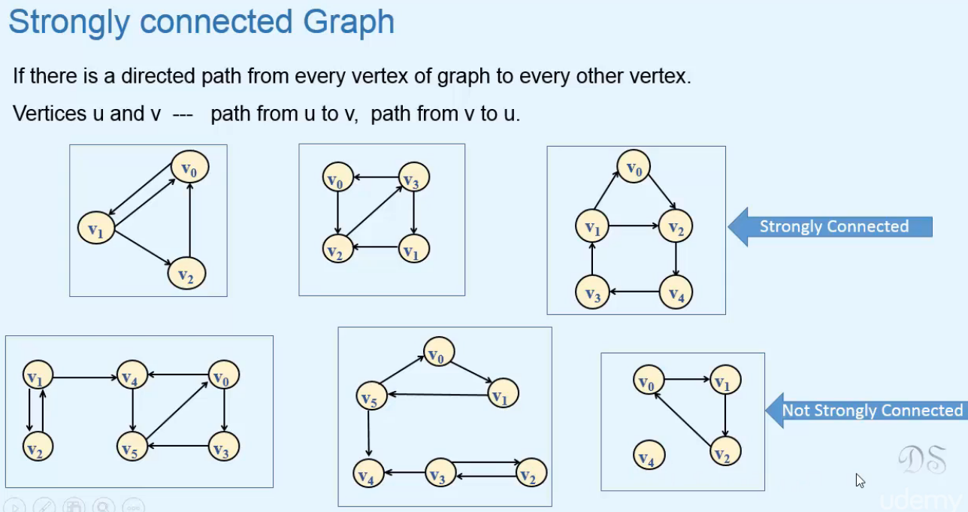  
**Strongly Connected Components**  
* A graph that is not strongly connected can have different parts that are strongly connected.  
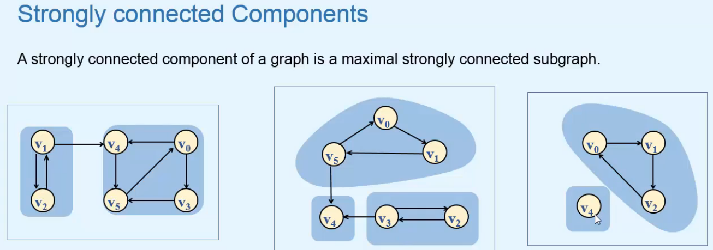

**Weakly Connected Graph**  
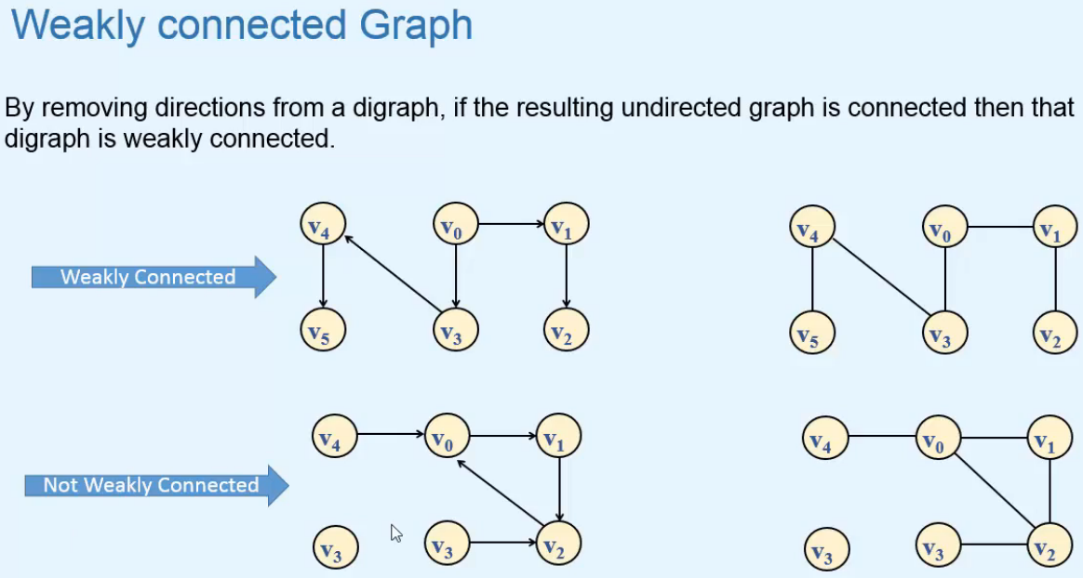

**Tree and Forest**  
**Tree**  
=> **Tree is an Acyclic Connected Graph**.  
=> **There’s only 1 path between any two vertices of a tree**.  
=> **n-1 edges where n are the vertices**.  
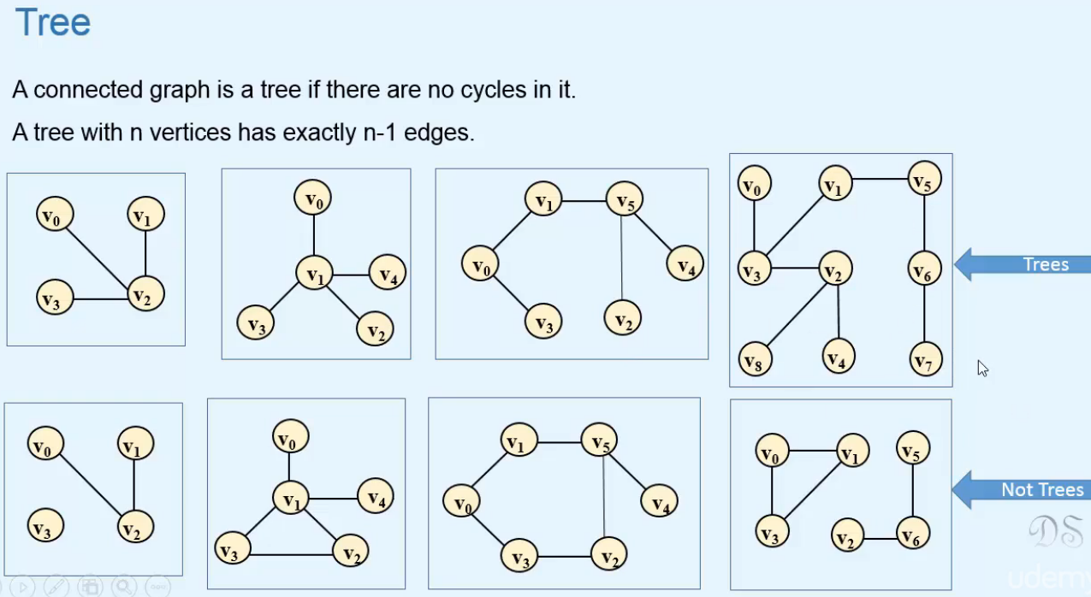

**Forest**  
=> **No path or 1 path between any two vertices**.  
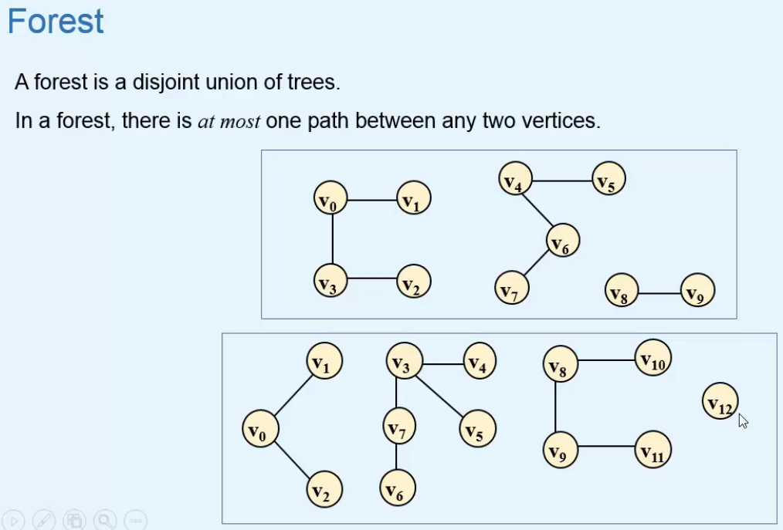  
**Spanning Tree**  
=> **They’re called Spanning Trees because they span over all the vertices of the graph**.  
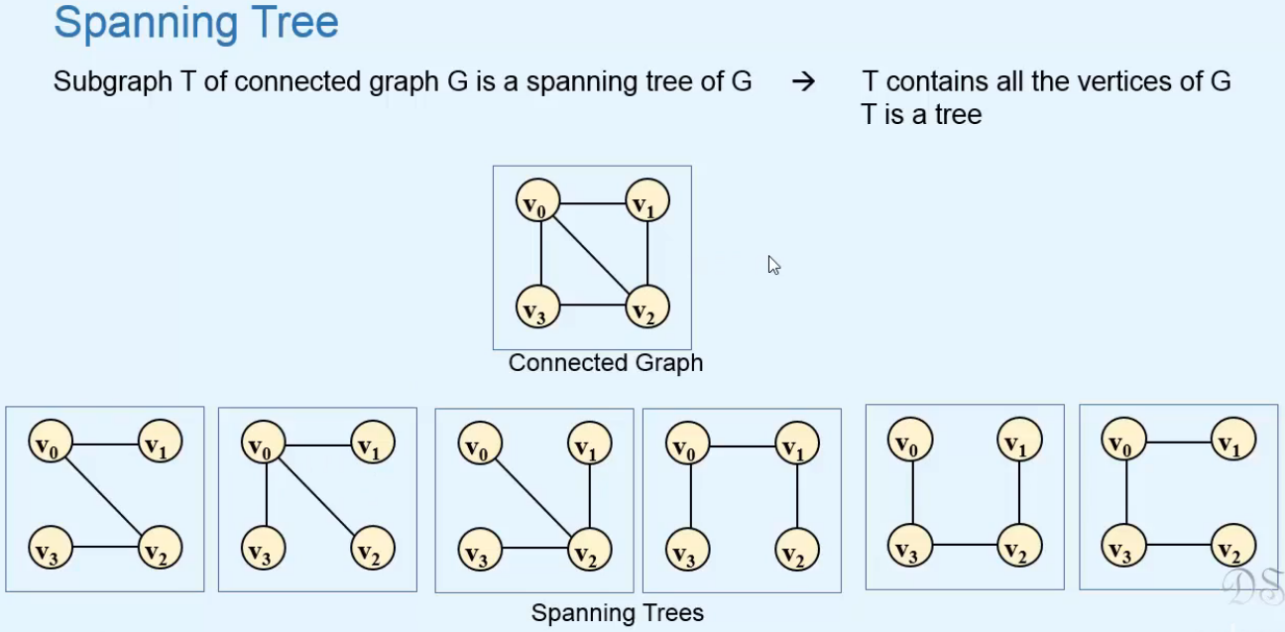

**Spanning Forest**  
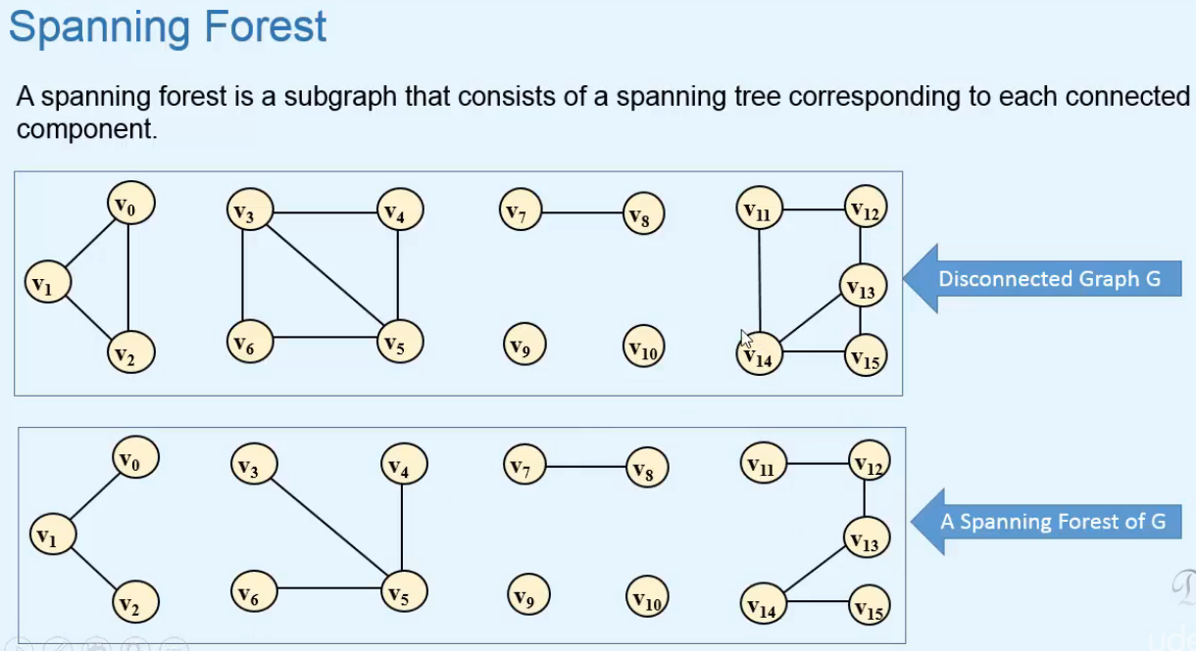

**Representation of Graph: Adjacency Matrix**  
* 2 ways of representing a graph:  
**1) => Sequential Representation** - **Adjacency Matrix**  
**2) => Linked Representation** - **Adjacency List  
Adjacency Matrix**  
=> **Represents a graph by storing the information of edges and vertices**.  
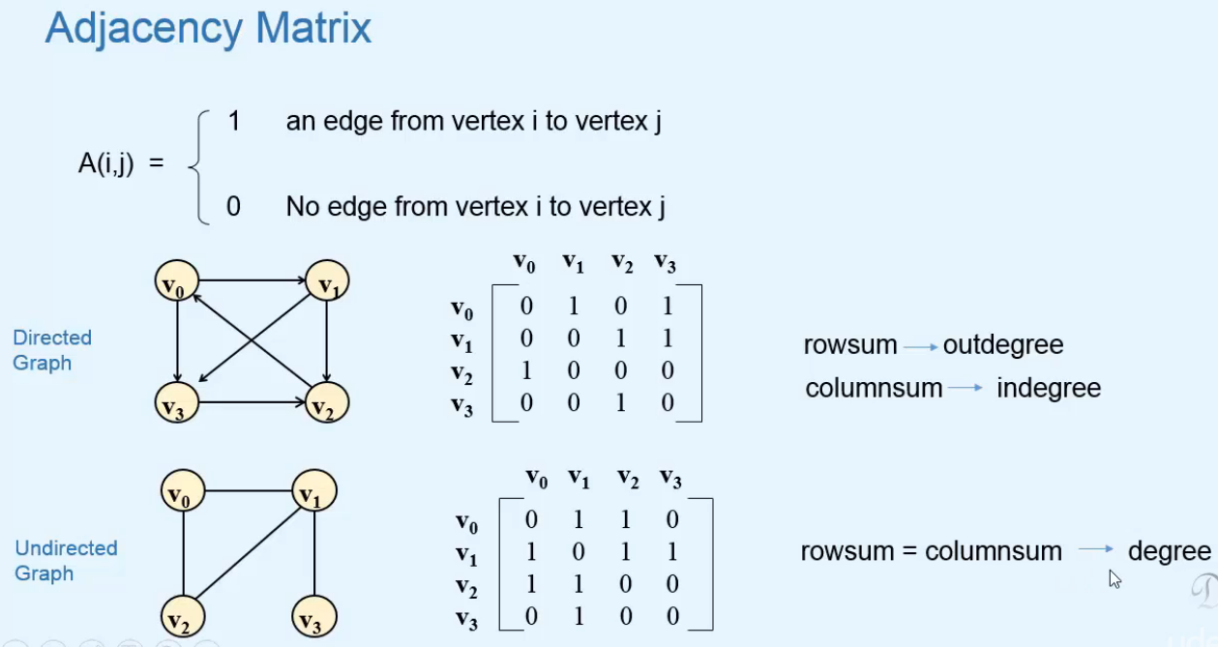  
=> **Adjacency Matrix for an Undirected Graph** is a **symetric matrix => A(i,j) = A(j,i)**.

* If we have a **Weighted Graph**, we can use this definition for filling the entries of the Adjacency Matrix.  
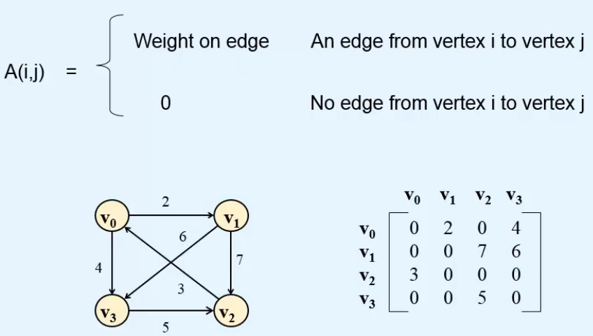  
**Inserting Edges  
Deleting Edges**  
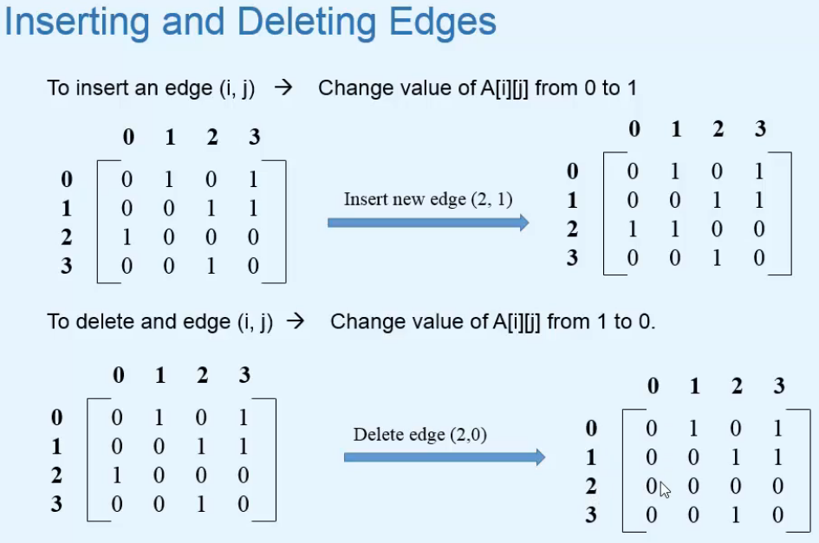  
**In Program**  
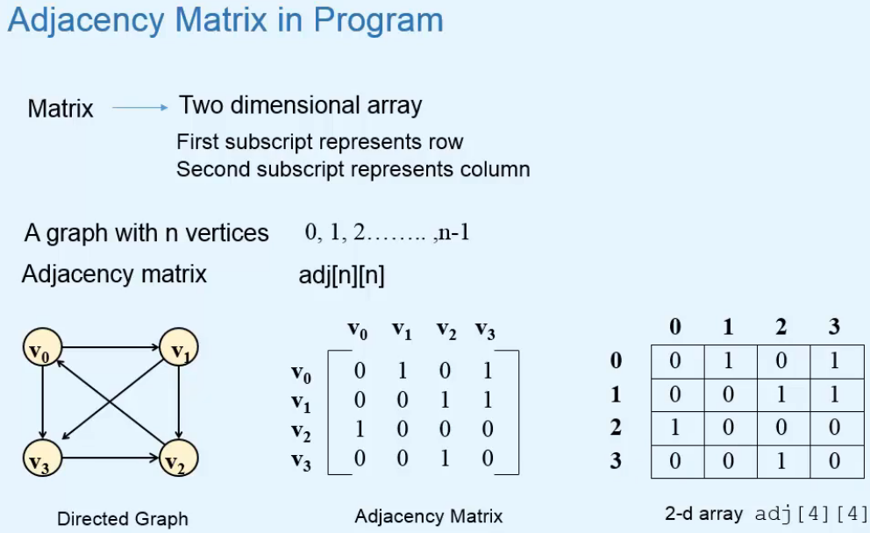

**Adjacency Matrix in Java**  
* We’ll add more data members later to the Vertex.  
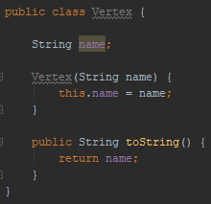  
* **n** = number of vertices in the graph.  
* **e** = number of edges in the graph.  
* **Let’s see why we need the getIndex() method**:  
=> We take the names of the vertices as arguments and all the work has to be done in the Adjacency Matrix and for that we need the index associated with the vertex name.  
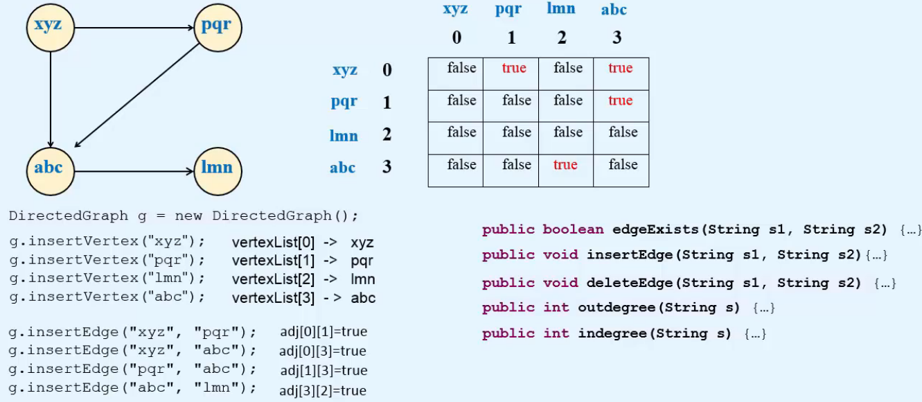  
**DirectedGraph**:  
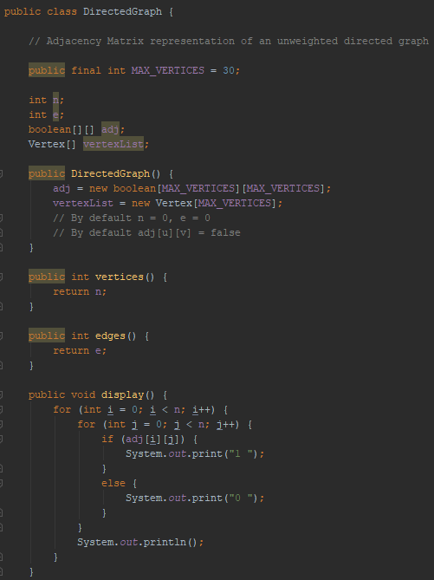 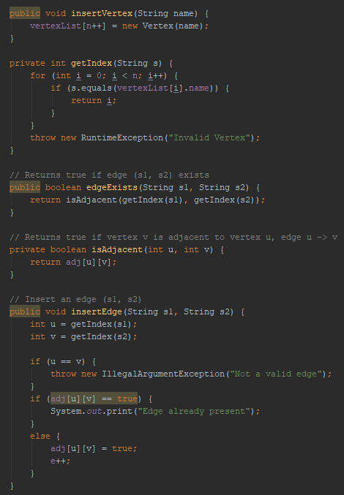  
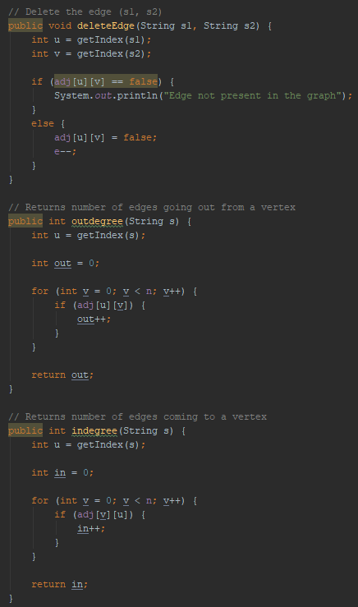

**UndirectedGraph**:  
=> differences:   
insertEdge()  
deleteEdge()  
degree()  
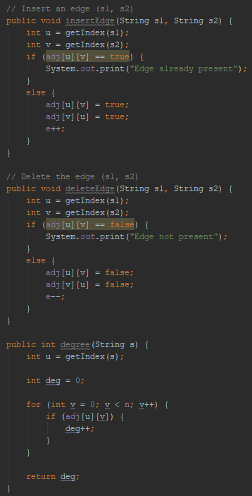  
**DirectedWeightedGraph**:  
=> differences:   
int[][] adj instead of boolean[][] adj  
  
display()  
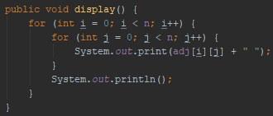  
isAdjacent()  
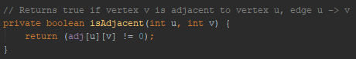

insertEdge()  
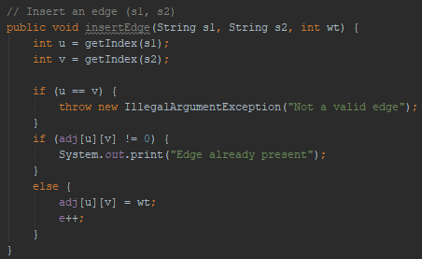  
deleteEdge()  
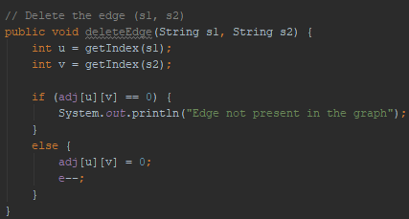  
outdegree ()  
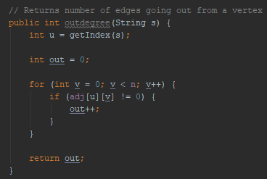  
indegree()  
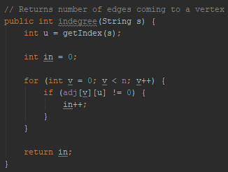

**UndirectedWeightedGraph**  
=> in a similar way to DirectedWeightedGraph.

**Representation of Graph: Adjacency List**  
**Vertex List**  
**Edge List (Adjacency List)**  
* Edge Lists are used to store references to adjacent vertices of a particular vertex, so we also call them Adjacency Lists.  
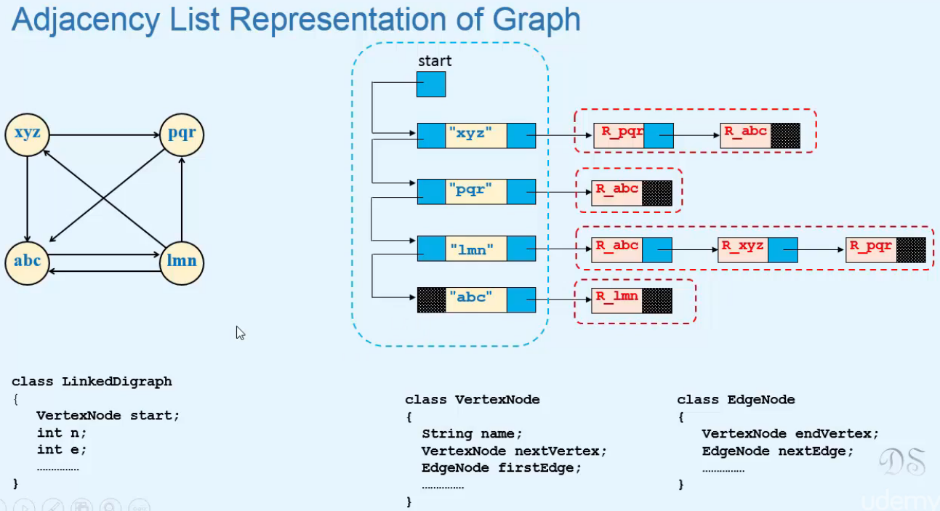  
* For deleting a vertex, we first delete all the references to it in all the vertices and then we delete the vertex itself with its references.

**Adjacency List in Java**  
**VertexNode EdgeNode**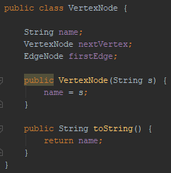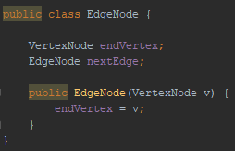

**LinkedDigraph**  
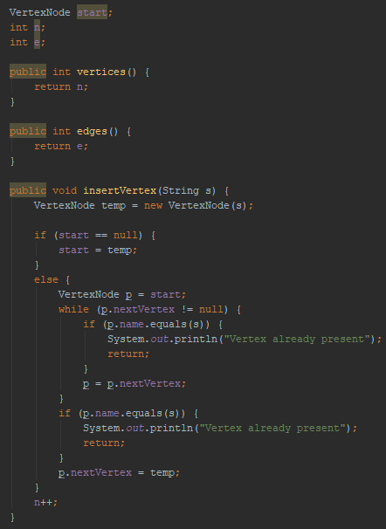   
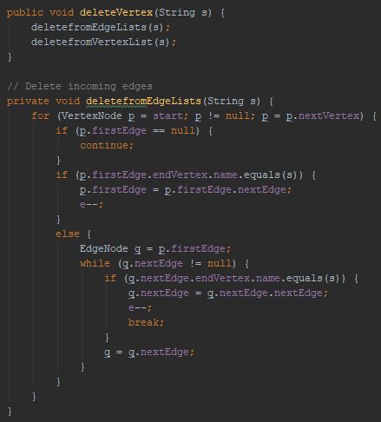 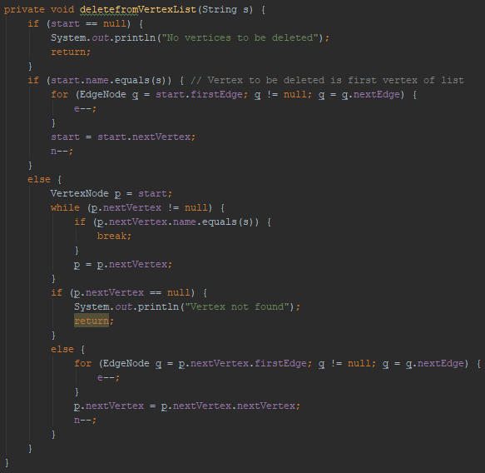  
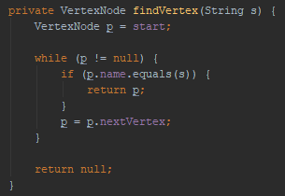

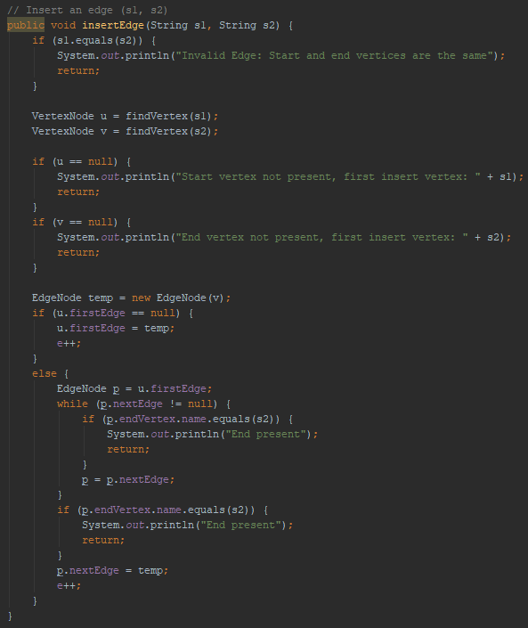

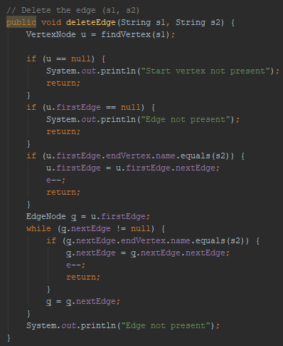

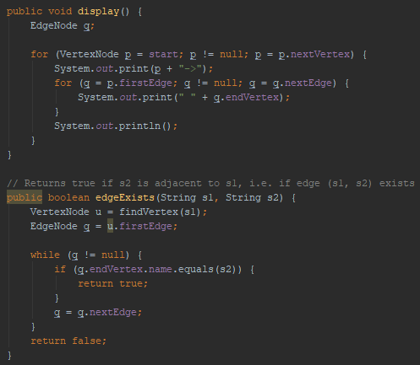 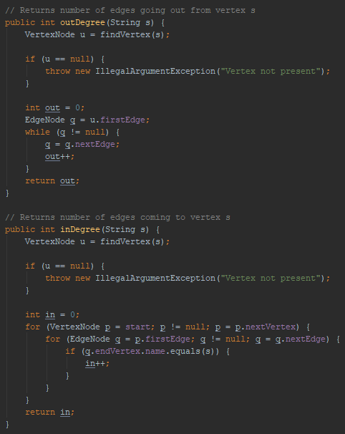

**LinkedUndirectedGraph**  
* **The number of edge nodes is double the number of edges**.  
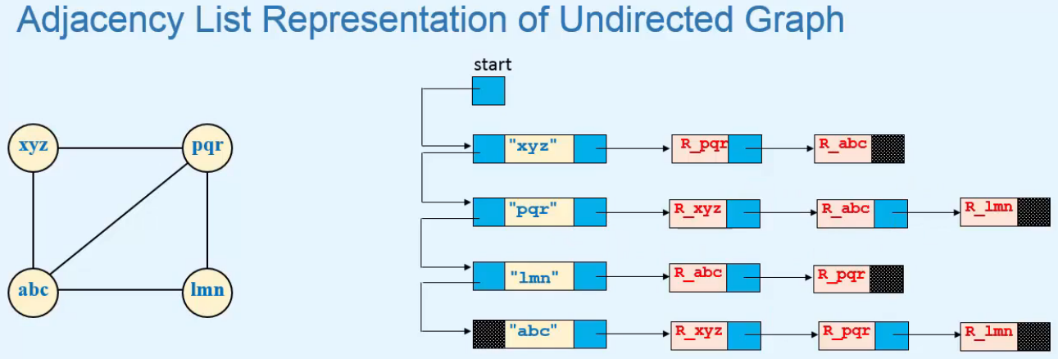

* **If we have a weighted graph, we can add a data member `weight` in the EdgeNode class**.

**Transitive closure of a directed graph and Path Matrix**  
**Transitive closure of a directed graph**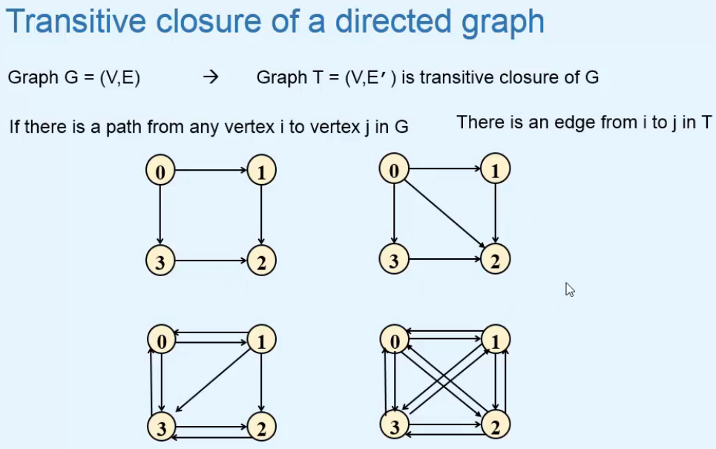  
=> **Graphs on the left are the directed graphs, the ones on the right are their Transitive Closures**.  
* In the top ones, there’s no path from 1 to 3, so there’s no edge from 1 to 3.  
* There’s no path from vertex 3 to 0, so there’s no edge from 3 to 0.  
* But there is a path from vertex 0 to 2, so there is an edge form 0 to 2.  
**Path Matrix = Reachability Matrix = Transitive Closure Matrix**  
=> **It’s actually the Adjacency Matrix of the Transitive Closure of the graph**.  
* To see if there’s a path from i -> j, we can look at the i-th row j-th column in the path matrix.  
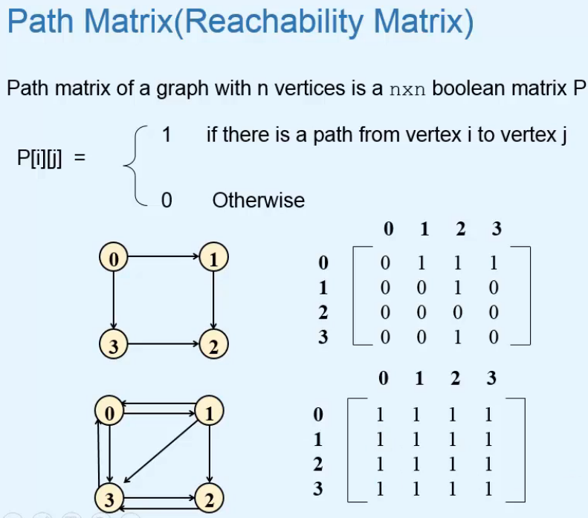

**Cyclic** => **Look at the main diagonal elements, if any of them is 1, there is a cycle in the graph**.

**Strongly Connected Graph** => **if all the elements are 1 in the Path Matrix.**\* Now let’s see 2 ways of computing the Path Matrix  
1) => **Adjacency Matrix**  
2) => **Warshall’s Algorithm**  
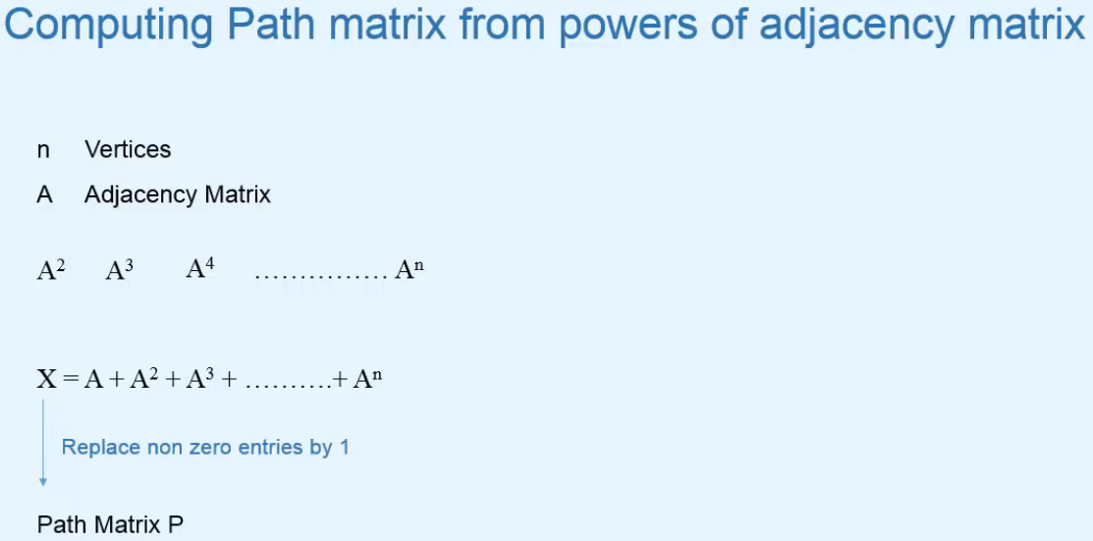  
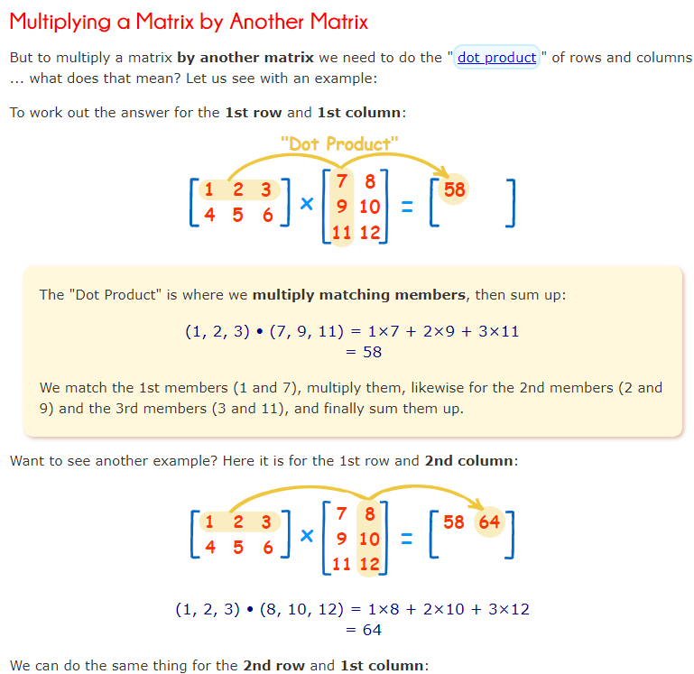  
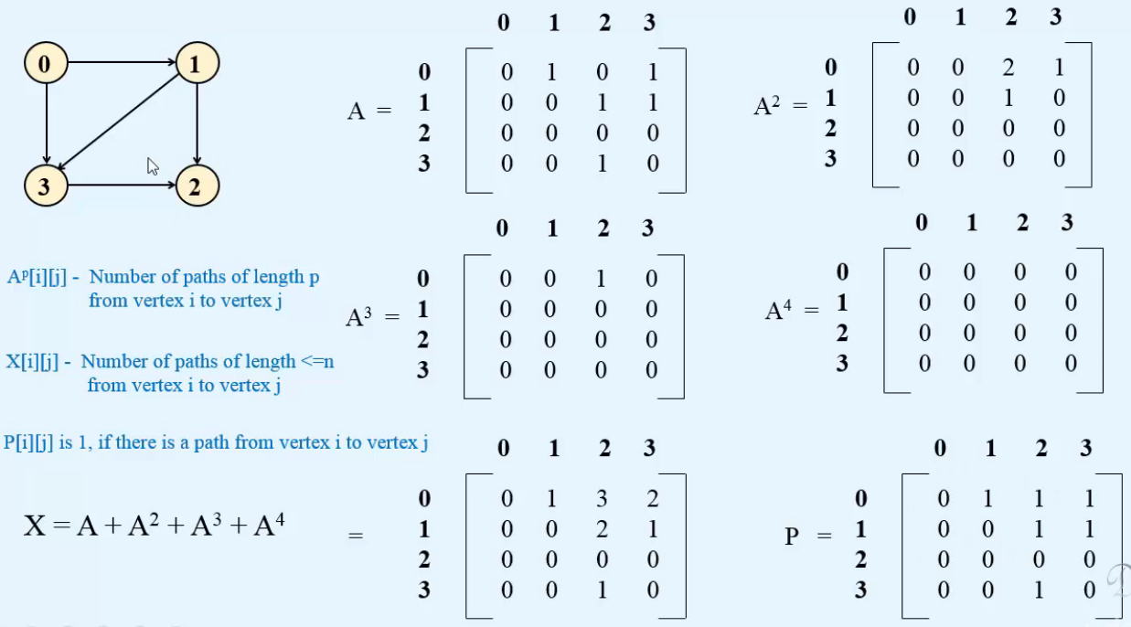

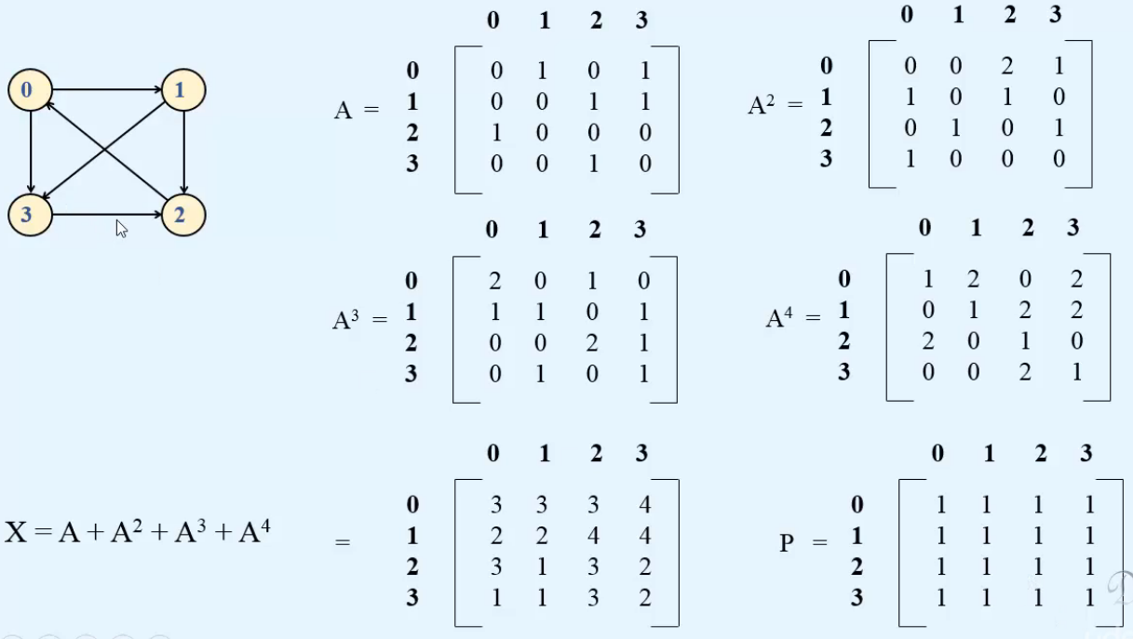  
=> Strongly Connected Graph since all the elements in the Path Matrix are 1.  
**Code**:  
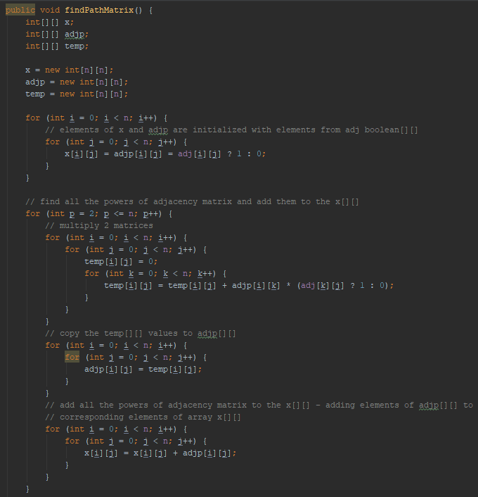

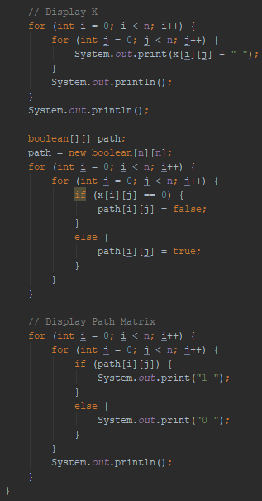

**Warshall’s Algorithm**  
* **Finding the Path Matrix**  
* P-1 = 1 => there’s an edge i -> j, so it’s the **Adjacency Matrix**.  
* Pn-1 => can use all the vertices in the graph, so it’s the **Path** **Matrix**.  
* **If we know how we can find matrix Pk from Pk-1, then we can easily find all these matrices**.  
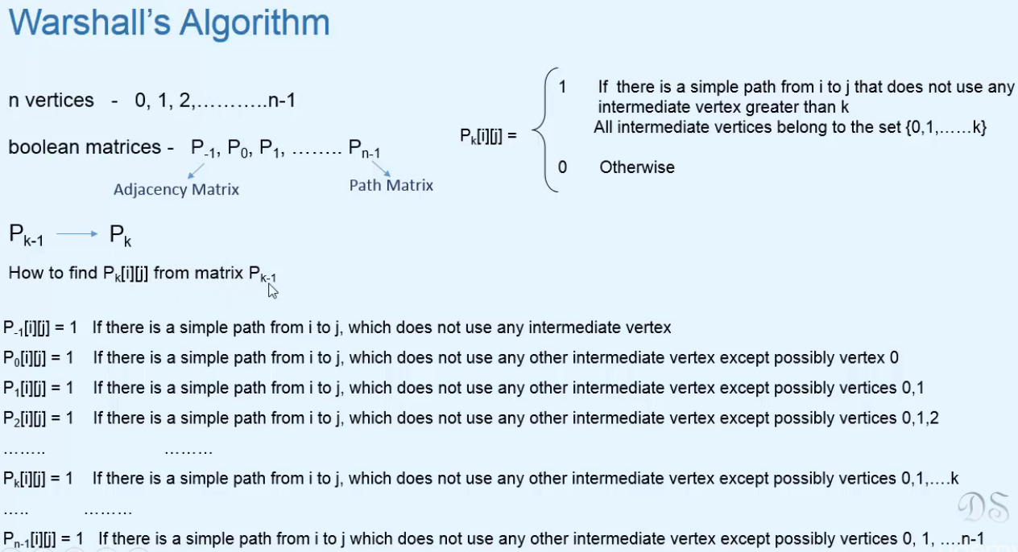

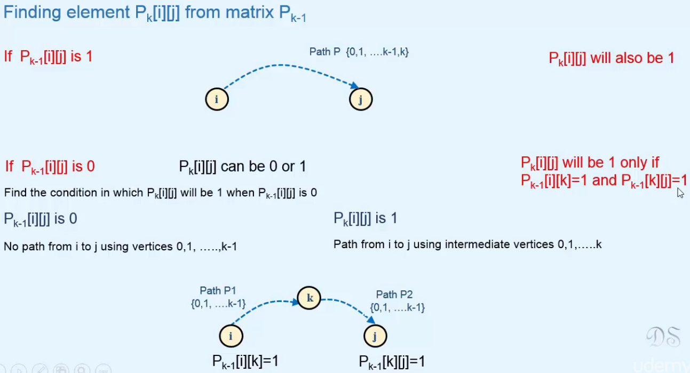  
=> **So for path P to exist between vertices i and j, the path i -> k and k -> j should exist**.  
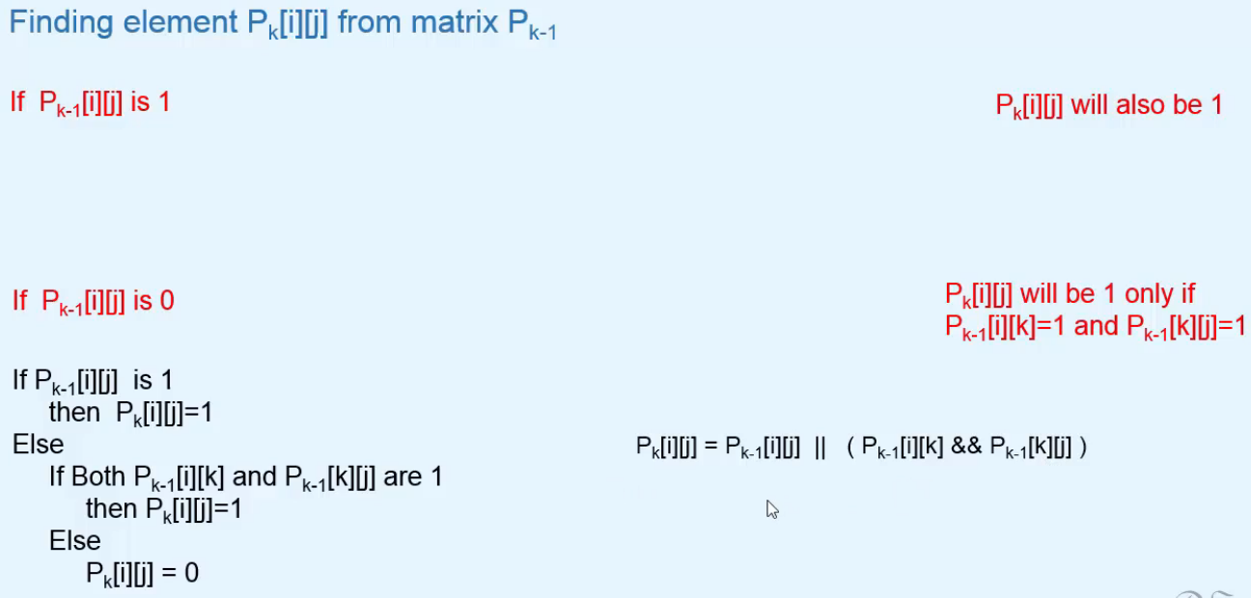  
* **We know that P-1 = Adjacency Matrix, we can find the other matrices from it**.  
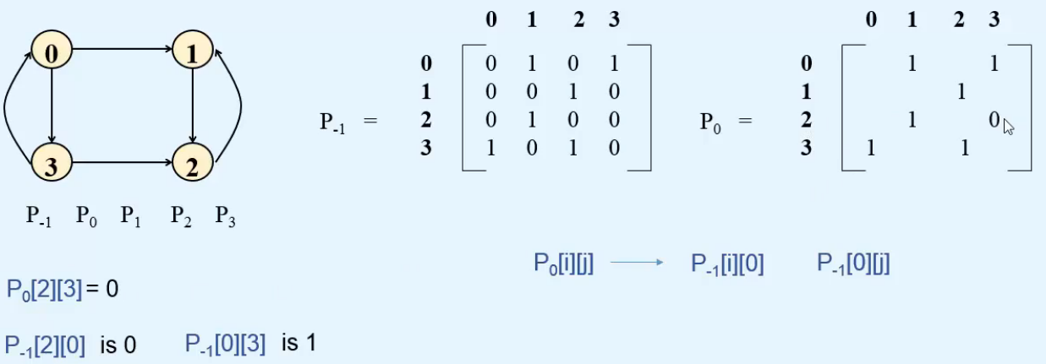

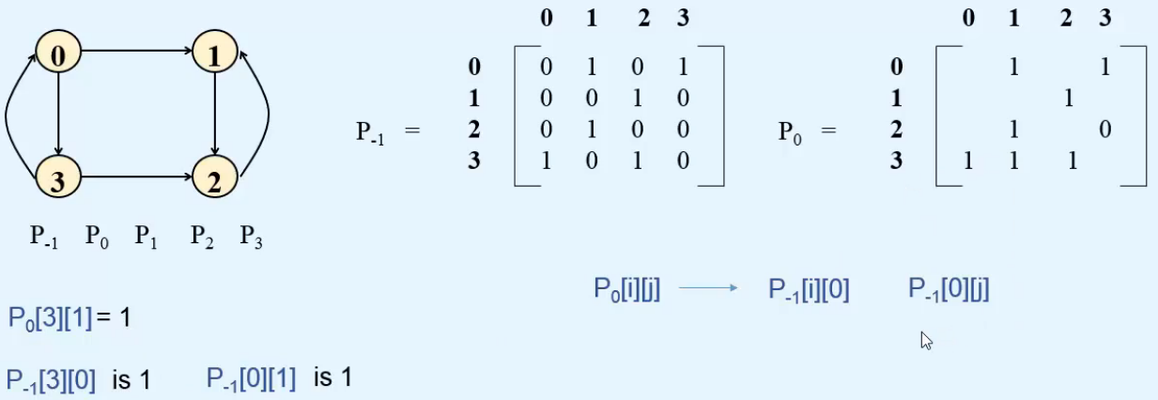

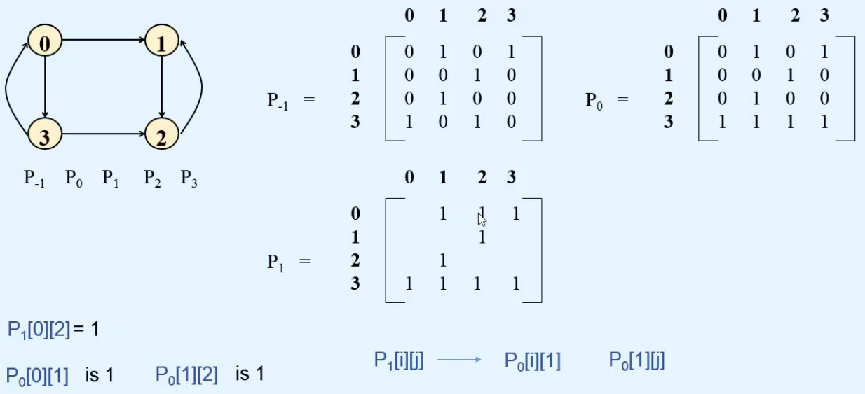  
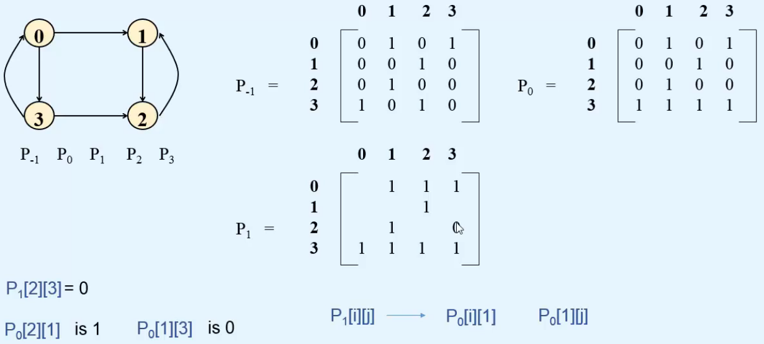

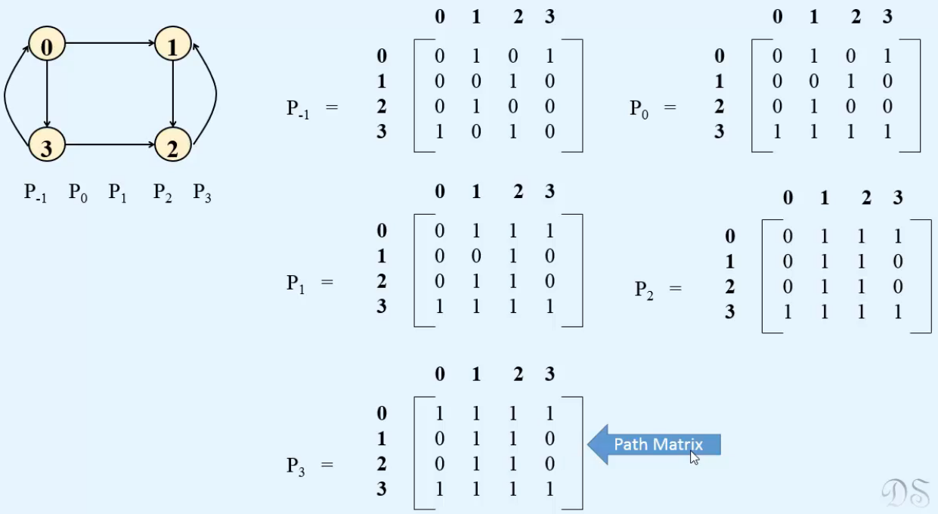

**Warshall’s Algorithm in Java**  
